Patent Draft

on

**Soil Testing and Crop Recommendation**

Submitted as a part of course curriculum for

**Bachelor of Technology**

in

**Computer Science**



**Sanjeev Kumar Rahul Singh Priyanshu Kumar**

2000290120133 2000290120122 2000290120118

[sanjeev.2024cs1054@kiet.edu](mailto:sanjeev.2024cs1054@kiet.edu) [rahul.2024cs1043@kiet.edu](mailto:rahul.2024cs1043@kiet.edu) [priyanshu.2024cs1112@kiet.edu](mailto:priyanshu.2024cs1112@kiet.edu)

**Under the Supervision of**

Anurag Mishra

Professor

**KIET Group of Institutions, Ghaziabad**

**Department of Computer Science**

**Dr. A.P.J. Abdul Kalam Technical University**

**2023-2024**

**DECLARATION**

We hereby declare that this submission is our work and that, to the best of our knowledge and belief, it contains no material previously published or written by another person nor material which to a substantial extent has been accepted for the award of any other degree or diploma of the university or other institute of higher learning, except where due acknowledgement has been made in the text.

Signature of Students

**Sanjeev Kumar Rahul Singh Priyanshu Kumar**

2000290120133 2000290120122 2000290120118

Date: 29-Aug-2023

**CERTIFICATE**

This is to certify that Project Report entitled “**Soil Testing and Crop Recommendation**” which is submitted by **Sanjeev Kumar, Rahul Singh and Priyanshu Kumar** in partial fulfilment of the requirement for the award of degree B. Tech. in Department of Computer Science of Dr A.P.J. Abdul Kalam Technical University, Lucknow is a record of the candidates own work carried out by them under my supervision. The matter embodied in this report is original and has not been submitted for the award of any other degree.

**Date: 29-Aug-2023 Supervisor Signature**

Anurag Mishra

(Professor)

**ACKNOWLEDGEMENT**

It gives us a great sense of pleasure to present the synopsis of the B.Tech Mini Project undertaken during B.Tech. Third Year. We owe a special debt of gratitude to Anurag Mishra (Professor), Department of Computer Science, KIET Group of Institutions, Delhi- NCR, Ghaziabad, for his/her constant support and guidance throughout the course of our work. Her sincerity, thoroughness and perseverance have been a constant source of inspiration for us. It is only his/her cognizant efforts that our endeavours have seen the light of the day.

We also take the opportunity to acknowledge the contribution of Dr. Ajay Kumar Shrivastava, Head of the Department of Computer Science, KIET Group of Institutions, Delhi- NCR, Ghaziabad, for his full support and assistance during the development of the project. We also do not like to miss the opportunity to acknowledge the contribution of all the faculty members of the department for their kind assistance and cooperation during the development of our project.

Last but not the least, we acknowledge our friends for their contribution to the completion of the project.

Signature:

Date : 29-Aug-2023

**Sanjeev Kumar Rahul Singh Priyanshu Kumar**

2000290120133 2000290120122 2000290120118

**INTRODUCTION**

A soil test is a process by which elements (nitrogen, phosphorus, potassium) which are present in the soil are measured for their "plant available" content within the sample. The quantity of available nutrients in the sample determines the amount of fertilizer that is recommended. A soil test also measures soil pH.

The soil is a vital natural resource which provides food to all living creatures in nature. The soil is basis of life in nature. A good quality soil can produce large amount food.

The use fertilizer helps in increasing the production of food to meet the demand by the whole world. As the population is increasing day by day the demand for the food is also increasing. But land available for the cultivation and production of crop is limited. This causes to utilize the full potential of land to produce food. And the fertilizer and pesticides help in producing the food.

But due to use excessive or less use of fertilizer the nutrients in the soil for crop keeps decreasing which eventually causes less production of food. To avoid this problem correct measure of nutrients available and needed by the soil for a particular soil should be done. Which helps crops to grow fast and healthy.

Crop also get affected by the disease which destroy the whole field. If right pesticides are used at the right time by detecting the type of pest that affecting the crop, loss of crop can be reduced.

**PROBLEM STATEMENT**

In the last few decades, it is observed that farmers are using fertilizer for the better production of crop. Because fertilizer provides necessary nutrients for higher production of crop. But it is also observed that farmer is using fertilizer in any quantity without knowing the actual nutritional need of the soil and plant which is grown.

Because of this there are some farmers who is using more chemical fertilizer as needed by a crop to grow. And there are some farmers who are using less fertilizer as needed by a crop to grow. This unmeasured use of fertilizer affects the cost of production and quantity of production, which ultimately affect the farmer and financial stability of farmer.

The excessive use of fertilizer also affects the soil and degrades its nutritional value for the crop. Some fertilizer which are excess in quantity also dissolve in water and causes water pollution.

A major problem that farmers are facing now days is that the crop gets affected by some disease and whole crop depraved by it. This loss of farmer can be minimized by the use of correct pesticides if the cause of disease identified at time.

**OBJECTIVES**

The main objective is to evaluate the fertility and nutrients status in the given soil and provide a recommendation on the amount of manure and fertilizer based on soil test value and according to crop.

To avoid excess use of fertilizer and to ensure environmental safety.

To test the soil timely, because each time when a crop a is harvested from the field, the soil losses a considerable amount of nutrients and causes loss of fertility over a long time.

Increasing the production of crop and profitability of farmer by providing necessary nutrients to the crop.

By the effective and efficient use of fertilizer and pesticides, the soil and water pollution can be reduced which eventually leads to cleaner environment.

Reduce the losses of crop due to crop disease.

**METHODOLOGY**

The type of fertilizer and amount needed by a particular crop is predicted using Machine Learning techniques such as Support Vector Machine (SVM), Artificial Neural Network (ANN), Random Forest (RF), Multivariate Linear Regression (MLR), and K-Nearest Neighbor (KNN) at the right time when it is required.

Using image recognition (CNN) technique, to find the disease in the plant and recommend possible solution of the disease which help to increase the production of the crop.

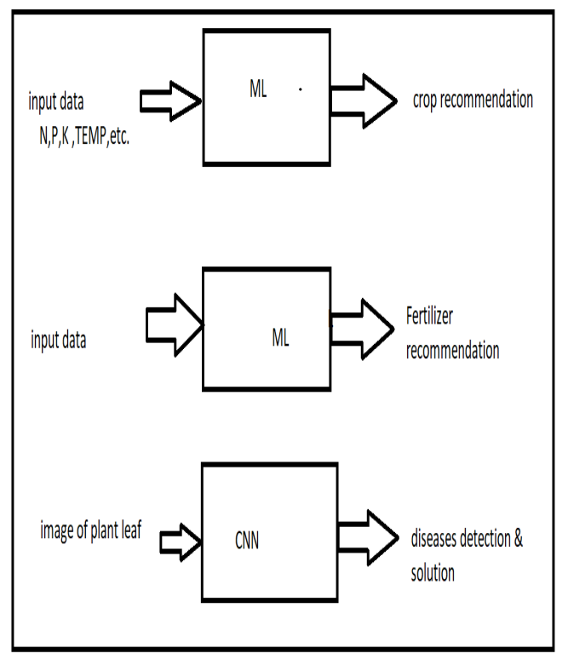

**SCOPE**

1. **IoT Sensor Integration and Data Collection:** This scope involves selecting, integrating, and deploying IoT devices with accurate sensors for measuring NPK values in the soil. The focus is on establishing a reliable data collection system that feeds real-time data to the analysis platform.
2. **AI-driven Data Analysis and Insights:** Developing advanced AI algorithms to process and analyze the collected soil nutrient data is essential. This scope includes creating models that can accurately interpret the data, detect nutrient imbalances, and generate actionable insights for farmers.
3. **Real-time Alert Generation and User Interface:** Building an intuitive and user-friendly interface is crucial for farmers to access real-time NPK data and receive alerts when nutrient imbalances are detected. This scope includes designing an interface that presents data visually and provides actionable recommendations.
4. **Testing and Validation in Real Conditions:** Rigorous testing of the entire system in real agricultural settings is vital to ensure accuracy and reliability. This scope involves both laboratory and field testing to validate the effectiveness of the IoT devices, sensors, AI algorithms, and the overall solution.
5. **Scalability and Sustainable Implementation:** Considerations for scalability are important to ensure the project can be expanded to accommodate a larger number of users and fields. Additionally, integrating sustainability principles, such as minimizing environmental impact and supporting long-term soil health, should be part of the scope.

**CLAIM**

**Claim 1: Enhanced Soil Nutrient Analysis through AI and IoT Integration**

This project harnesses the power of AI and IoT devices to provide accurate and real-time analysis of essential soil nutrients—Nitrogen (N), Phosphorus (P), and Potassium (K)—in agricultural fields. By seamlessly integrating advanced sensors and data analytics, we empower farmers with precise insights, leading to optimal nutrient management decisions and improved crop yields.

**Claim 2: Real-time Monitoring and Alerts for Optimal Nutrient Balance**

With our AI-based solution, farmers can monitor the NPK values of their soil in real time. The system analyzes data from IoT devices installed in the fields, instantly assessing nutrient levels and generating alerts when imbalances or deficiencies are detected. This proactive approach allows farmers to take immediate corrective actions, preventing crop health issues and optimizing fertilization strategies.

**Claim 3: Data-Driven Decision Making for Sustainable Agriculture**

This project revolutionizes agriculture by enabling data-driven decision-making. By continuously collecting and analyzing soil nutrient data through IoT devices, farmers gain valuable insights into the changing nutritional needs of their crops. This informed approach minimizes overuse of fertilizers, reduces environmental impact, and promotes sustainable farming practices, ultimately contributing to long-term soil health and productivity.

**Claim 4: Accessibility and User-Friendly Interface for Farmers**

It prioritizes accessibility and ease of use in our AI-based solution. The interface is designed to be user-friendly, allowing farmers, even those without technical expertise, to effortlessly navigate and interpret the collected data. Our project bridges the gap between cutting-edge technology and practical implementation, empowering farmers to harness AI and IoT for precision agriculture without any barriers.

**CONCLUSION**

The food demand of the world can be meet by effective use of the available resources. The use fertilizer of right type, in right amount and at the right time can help to full the food demand of the world in an effective manner and without harming our environment such as soil and water pollution. This leads to a clean environment.

Crop production can also be increased by the right use pesticides at the right time in right quantity, which save crop from any disease.

In conclusion, this AI-based project integrating IoT devices for soil nutrient analysis represents a significant step forward in modern agriculture. By leveraging advanced technology to monitor and analyze Nitrogen (N), Phosphorus (P), and Potassium (K) values in real time, we empower farmers with accurate insights into their soil's nutritional status. This information, delivered through a user-friendly interface, supports data-driven decision-making and enables precise fertilization strategies.

The project's proactive approach, generating alerts for nutrient imbalances, not only ensures healthier crops but also contributes to sustainable farming practices. By minimizing overuse of fertilizers and reducing environmental impact, we promote the long-term health of both soil and crops. This initiative represents a pivotal shift towards smarter, more efficient agriculture, where technology meets practicality to address the challenges of feeding a growing global population while preserving our planet's resources.

As we move forward, this project's success will inspire further innovations at the intersection of AI, IoT, and agriculture. Through continued collaboration between technology experts, agronomists, and farmers, we can refine and expand upon this foundation, creating a more resilient and productive agricultural sector. Ultimately, our project's legacy will be defined by its contribution to sustainable food production, environmental stewardship, and the empowerment of farmers worldwide.

**TABLE OF CONTENTS**

|  |  |  |
| --- | --- | --- |
|  | | Page No. |
| TITLE PAGE .................................................................................................................... | | i |
| DECLARATION .............................................................................................................. | | ii |
| CERTIFICATE …........................................................................................................... | | iii |
| ACKNOWLEDGEMENT.................................................................................................. | | iv |
|  | |  |
| CHAPTER 1 INTRODUCTION | | 1-4 |
| 1.1.          Introduction ……………………................................................... | | 1 |
| 1.2 Problem Statement .……………………....................................... | | 2 |
| 1.2.          Objective………………………………………………………… | | 3 |
| 1.3.          Scope…………………………………………………………….. | | 4 |
| CHAPTER 3 PROPOSED METHODOLOGY …………………………………........ | | 5 |
| 3.1 Flowchart | |  |
| CHAPTER 4 CLAIMS ………..………………………..…………………………… | | 6 |
|  |
| CHAPTER 6 CONCLUSION …....................................................................................... | | 7 |

.